# Optimizing User, Group, and Role Management with Access Control and Workflows — Final Project Report

**1. INTRODUCTION**

#### **1.1 Project Overview**

The "Optimizing User, Group, and Role Management with Access Control and Workflows" project focuses on streamlining project management for small teams by introducing structured roles, secure access control, and automated task workflows. The solution addresses ambiguities in role responsibility and lack of accountability by clearly defining permissions and automating task tracking using ServiceNow's low-code platform.

#### **1.2 Purpose**

The purpose of this project is to implement a secure, role-based task management system that enables project teams to efficiently manage and track their responsibilities. By establishing structured access control and workflows, the system reduces confusion, improves accountability, and supports smooth project execution.

This project also showcases the versatility of the ServiceNow platform in addressing non-IT use cases through innovative configurations and automation.

**2. IDEATION PHASE**

**2.1 Problem Statement**

The current project management process lacks clarity in task ownership, role definitions, and access control. This causes confusion, delays in task completion, and difficulty in tracking progress. There is a need for a well-defined role structure, secure data access, and a workflow that supports smooth task execution and visibility.

**2.2 Empathy Map Canvas**

* **Says:** "I don’t know what tasks I’m responsible for." "I need clear visibility on project updates."
* **Thinks:** "Am I allowed to access this section?" "Who is supposed to handle this?"
* **Does:** Checks task status manually; Asks for clarification on roles.
* **Feels:** Confused, unproductive, and disconnected from project workflow.

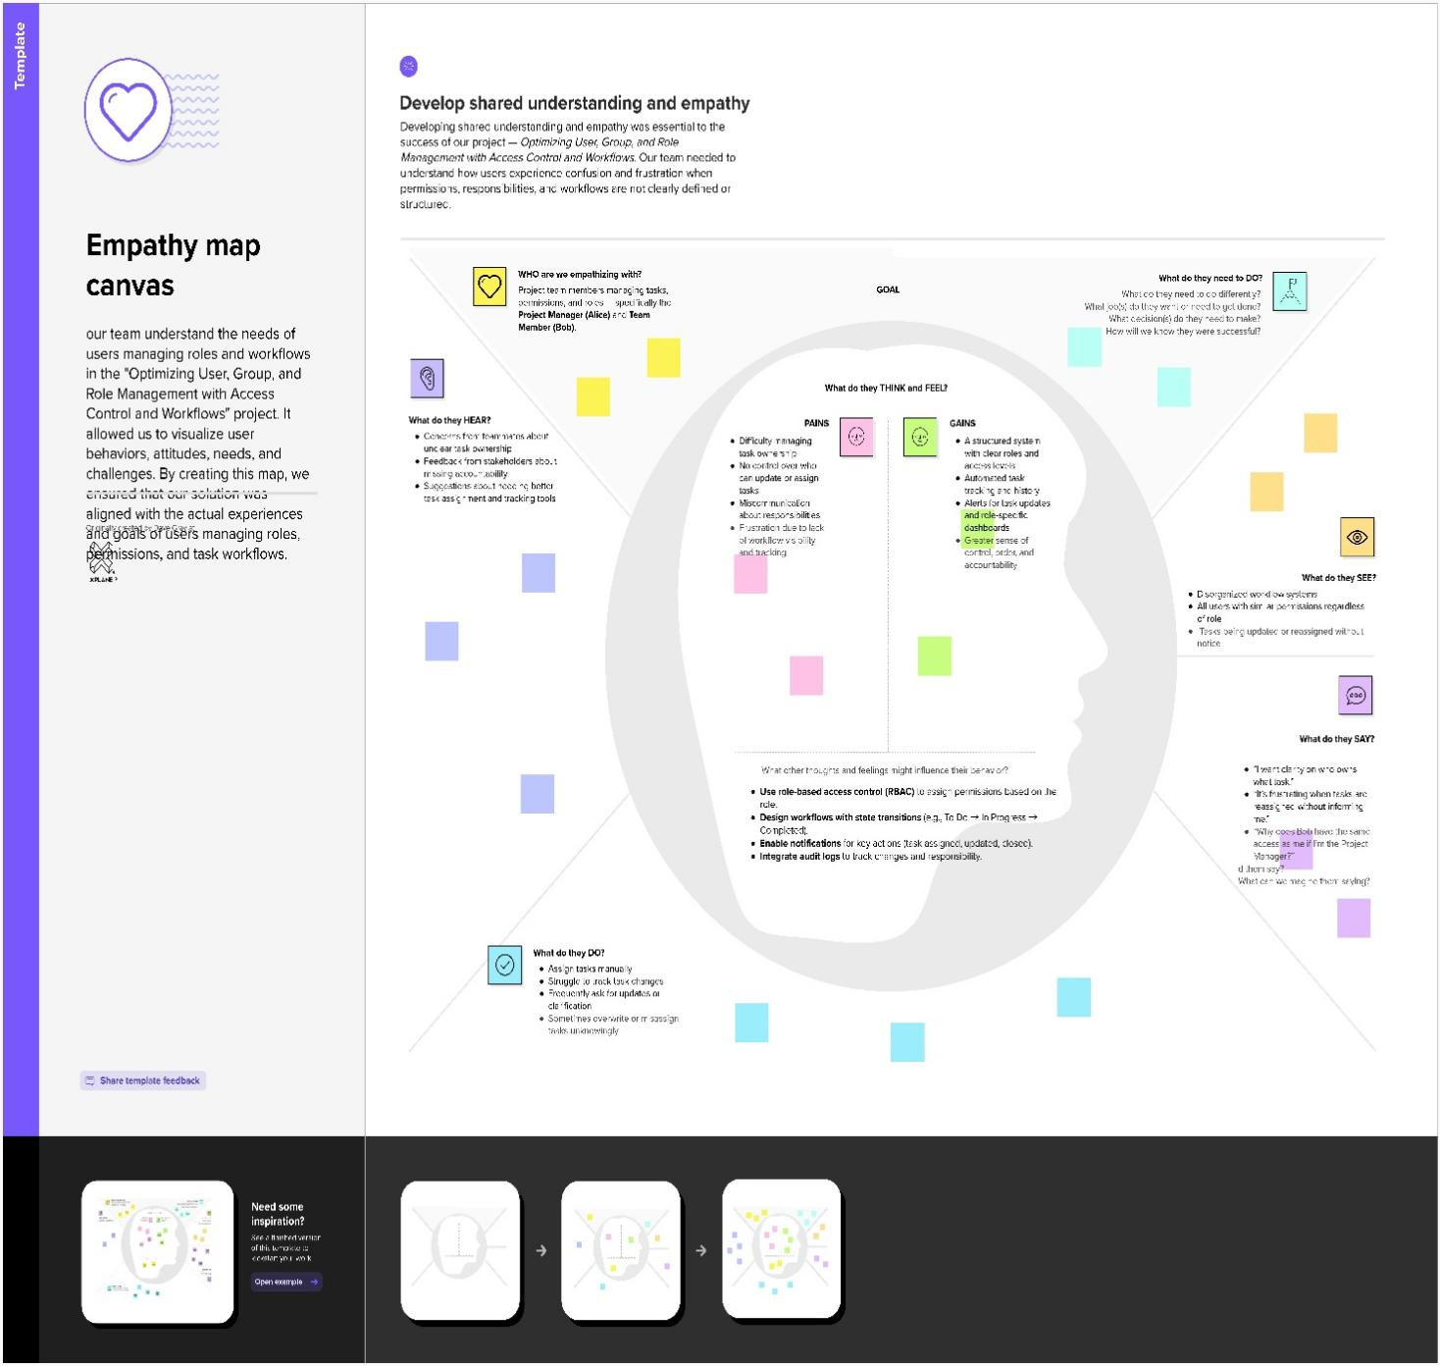

**2.3 Brainstorming**

The team proposed implementing to explore possible solutions for the identified problem in managing users, groups, roles, and workflows within small project teams. The objective was to find effective ways to enforce accountability and structured task handling by using ServiceNow’s capabilities.This collaborative phase allowed the team to express a wide variety of ideas related to access control, automation, and workflow design. The emphasis was on generating both conventional and innovative suggestions without immediate evaluation.

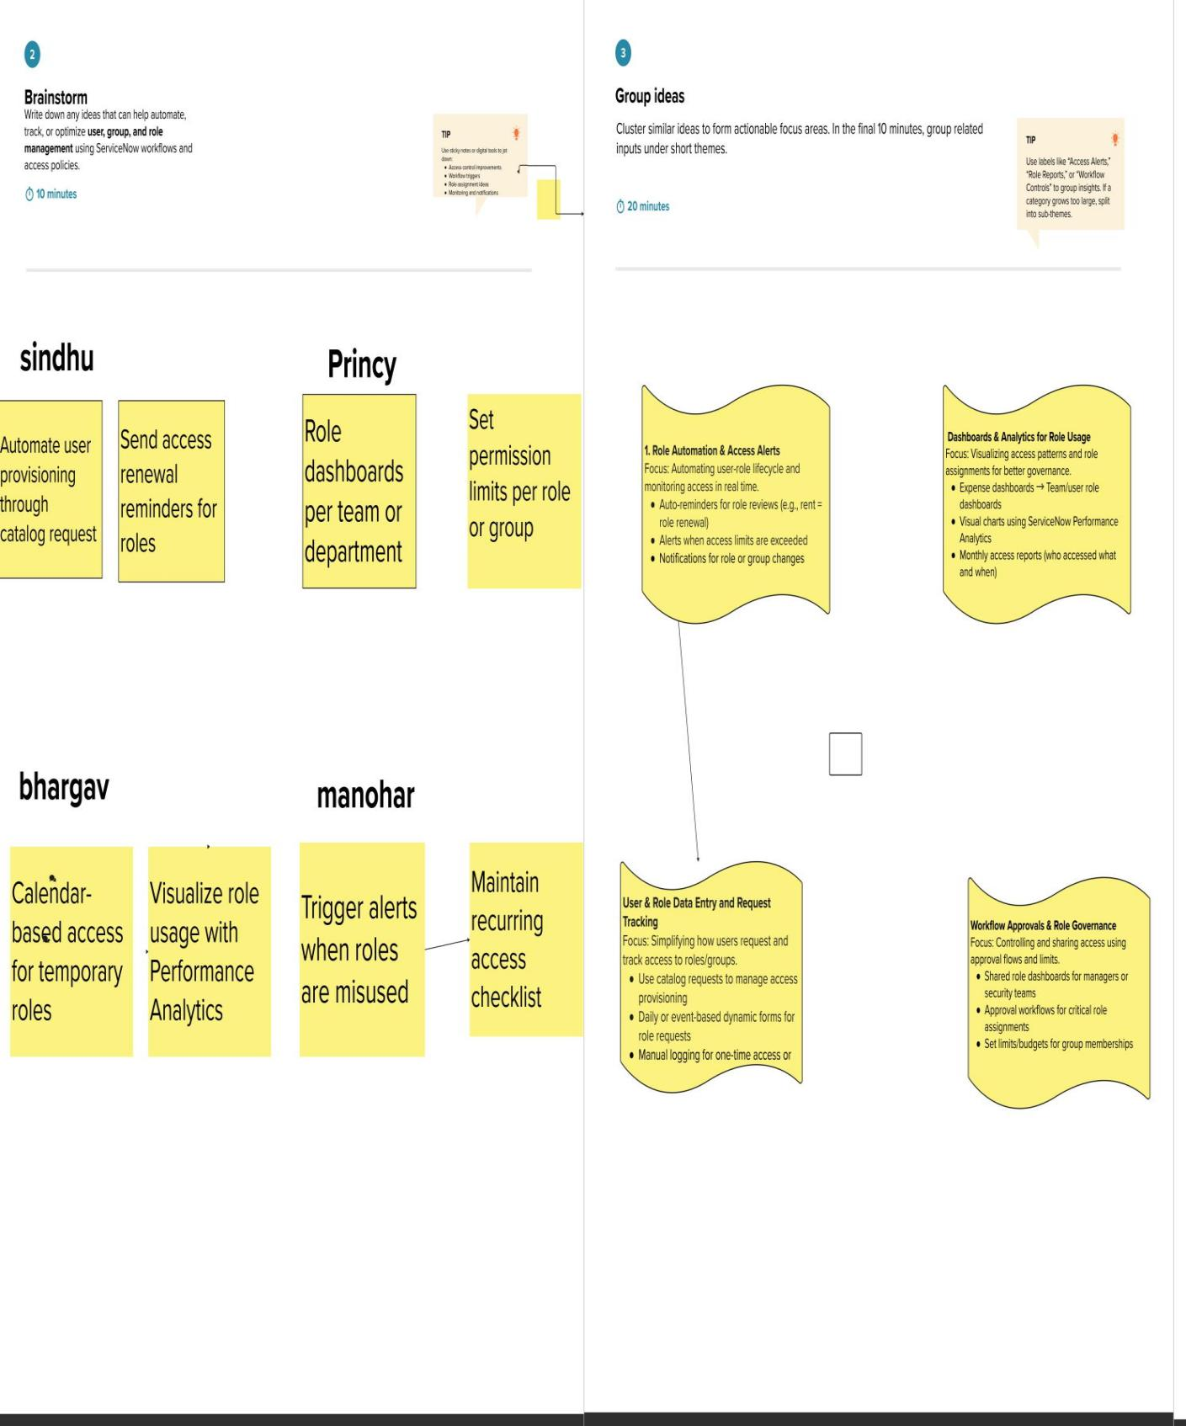

**3. REQUIREMENT ANALYSIS**

**3.1 Customer Journey Map**

Users log into the system, are assigned a role, and interact with the platform to view or update tasks based on their access. Project Managers assign and track tasks, while team members update status and view assigned work.

**3.2 Solution Requirement**

· Custom tables: Users, Roles, Tasks

· ACLs for controlled access

· Group-based permissions (Project Manager, Team Member)

· Task workflows

· Notifications on task updates

· Dashboard for role-specific task views

**3.3 Data Flow Diagram**

A **Data Flow Diagram (DFD)** for this project illustrates how project tasks, user roles, and workflows interact within the system. The diagram highlights the entry of user task data, its transformation through business rules, and its controlled visibility via access control mechanisms. Core entities include Project Manager (Alice), Team Member (Bob), Project Tasks, and the Access Control Layer.

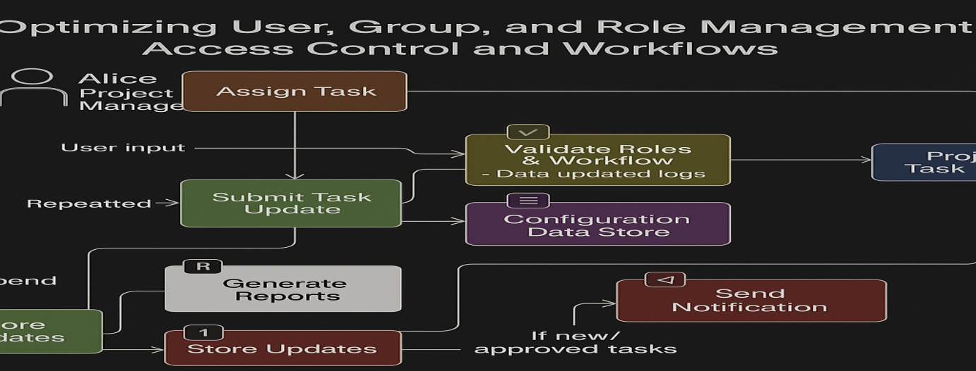

**3.4 Technology Stack**

· **Platform**: ServiceNow PDI

· **Logic**: Business Rules, UI Policies, ACLs

· **UI**: Custom Forms, Views

· **Database**: MySQL (via ServiceNow)

· **Optional**: REST API for future integrations

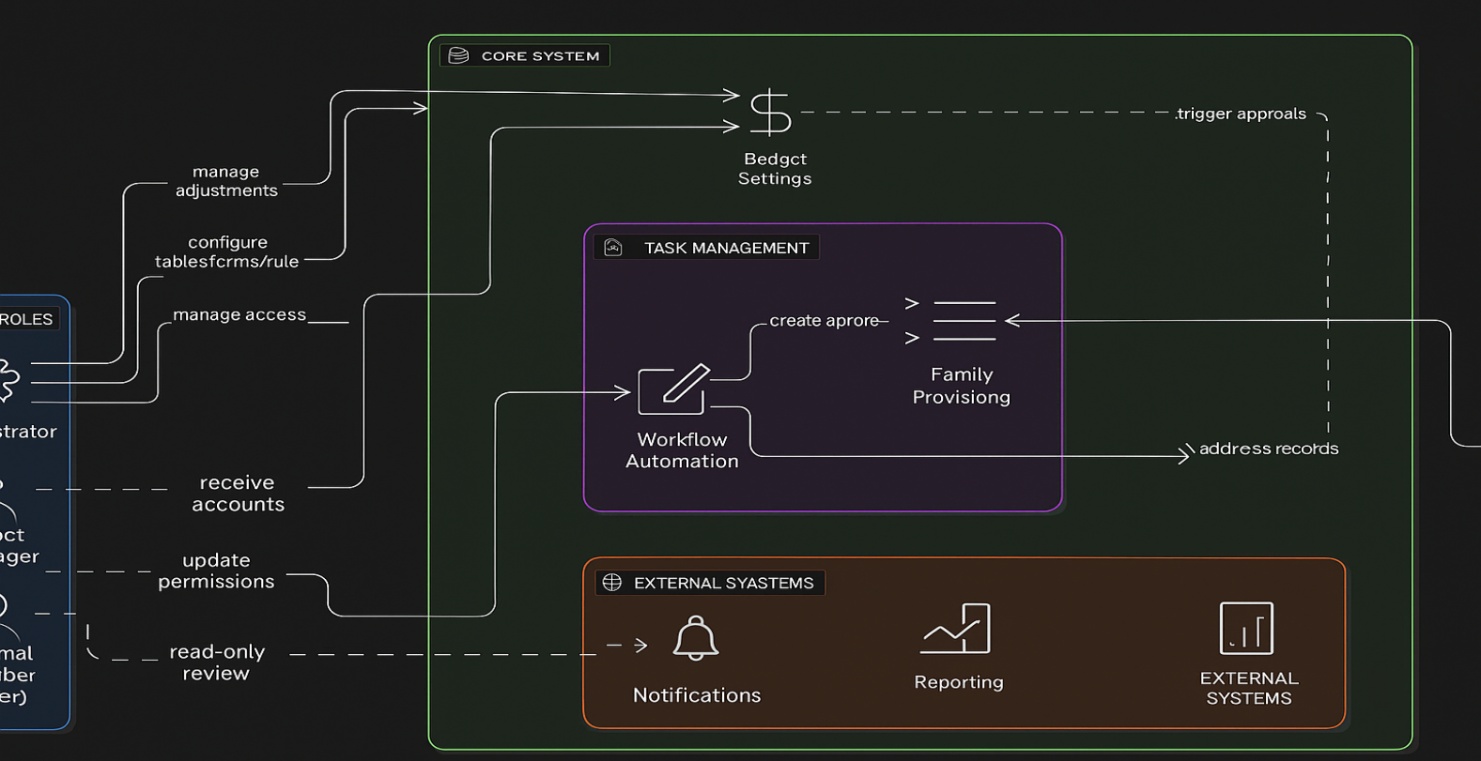

**4. PROJECT DESIGN**

**4.1 Problem–Solution Fit**

The system solves the problem of disorganized expense tracking by providing a centralized platform linking daily expenses to budgets, automating alerts, and simplifying reporting.

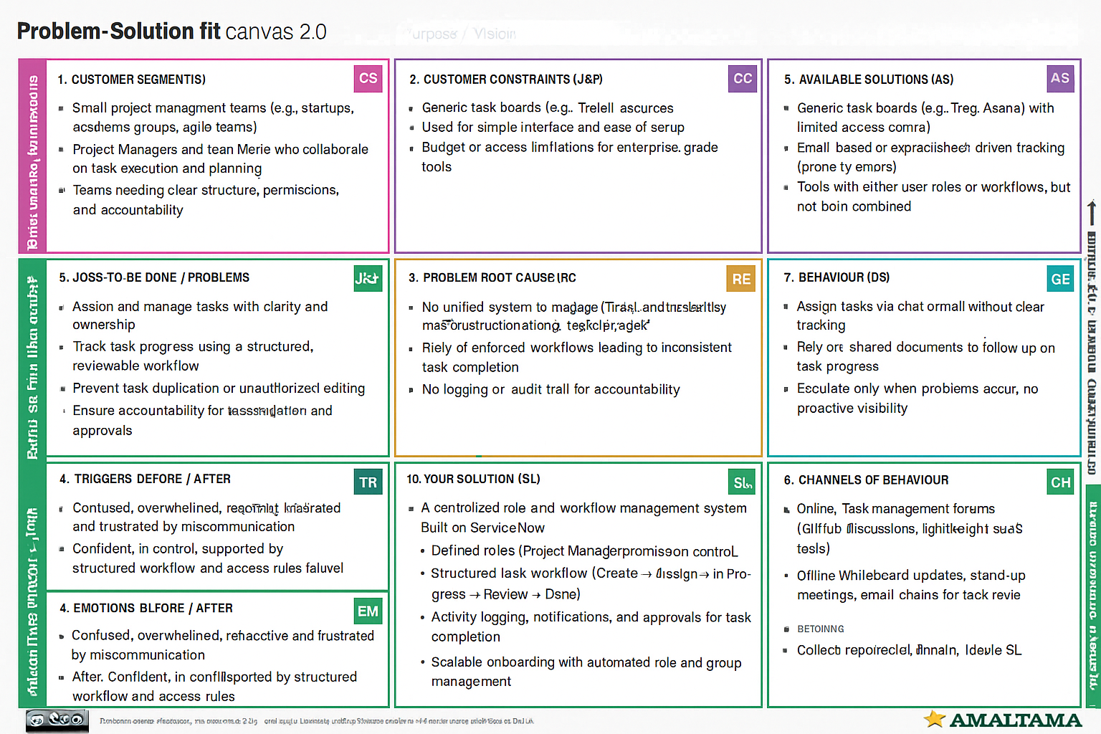

**4.2 Proposed Solution**

· User table with role attributes

· Group and role creation (e.g., PM Group, Developer Group)

· Task table with status field (To Do, In Progress, Done)

· ACLs to control who sees/edits what

· Workflow automation for task updates

· Notifications and dashboards

**4.3 Solution Architecture**

The architecture includes:

· **Data Layer**: User, Group, Role, Task tables

· **Logic Layer**: ACLs, Business Rules

· **UI Layer**: Role-based Dashboards, Forms

· **Automation Layer**: Notifications, Workflows

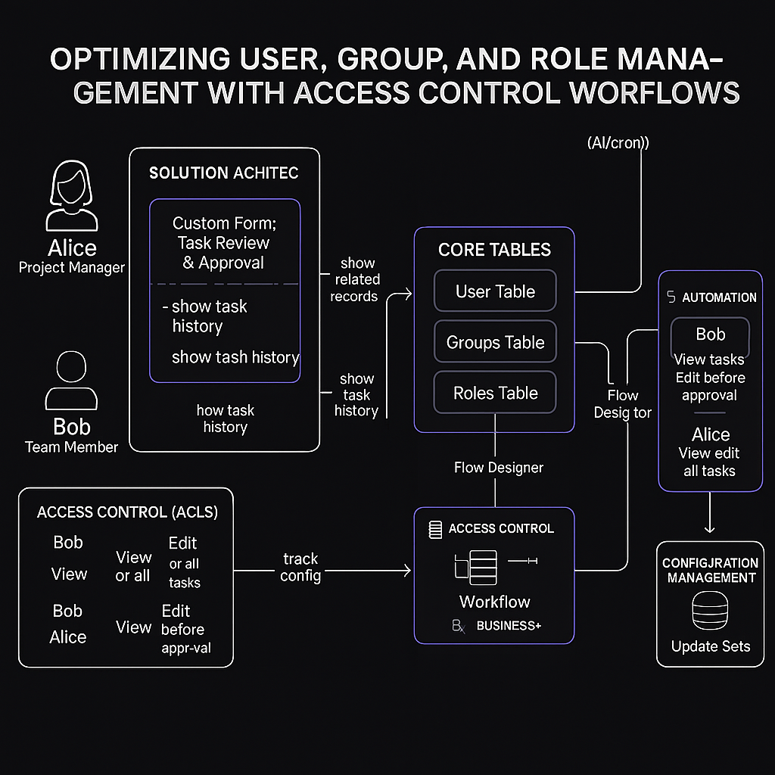

**5. PROJECT PLANNING & SCHEDULING**

**5.1 Project Planning**

The project was completed over 3 sprints:

* **Sprint 1:** Table setup, Update Set, Role Design (8 points)
* **Sprint 2:** Group creation, ACLs, Workflows (4 points)
* **Sprint 3:** Notifications, Dashboards, Testing (5 points)

## Velocity:

## For a 3-day sprint, total story points = 17

**Average Velocity (AV)** = **17 / 3**

= **5.67 story points/day**

The Project was completed as the following milestones covering 3 sprints

The team executed these milestones:

## Milestone 1: Understanding the Problem

### Problem Context:

In a small project team setup, such as one involving a Project Manager (Alice) and a Team Member (Bob), inefficient handling of user roles, group definitions, and permissions often leads to confusion in task assignment and accountability. The current system does not support structured workflows or role-based access, resulting in overlapping responsibilities and security gaps.

## Milestone 2: Goal Identification

### Objectives:

* Define clear user roles (e.g., Manager vs. Contributor)
* Restrict actions using role-based access control (RBAC)
* Automate workflow stages like task creation, assignment, completion, and closure
* Improve accountability via audit logs and notifications

## Milestone 3: Instance Setup on ServiceNow

* Created and activated a ServiceNow Developer Instance from [developer.servicenow.com](servicenow)
* Logged in using the instance credentials
* Verified the environment for custom development

## Milestone 4: Create Update Set

* Navigated to: **Local Update Sets**
* Created a new update set: AccessControlWorkflow
* Made it current for capturing all customizations

## Milestone 5: Role Definition Table Creation

* Created a new table: Role Definitions
* Fields included: Role Name, Permissions, Description
* Configured auto-numbering and number maintenance with prefix: RWF

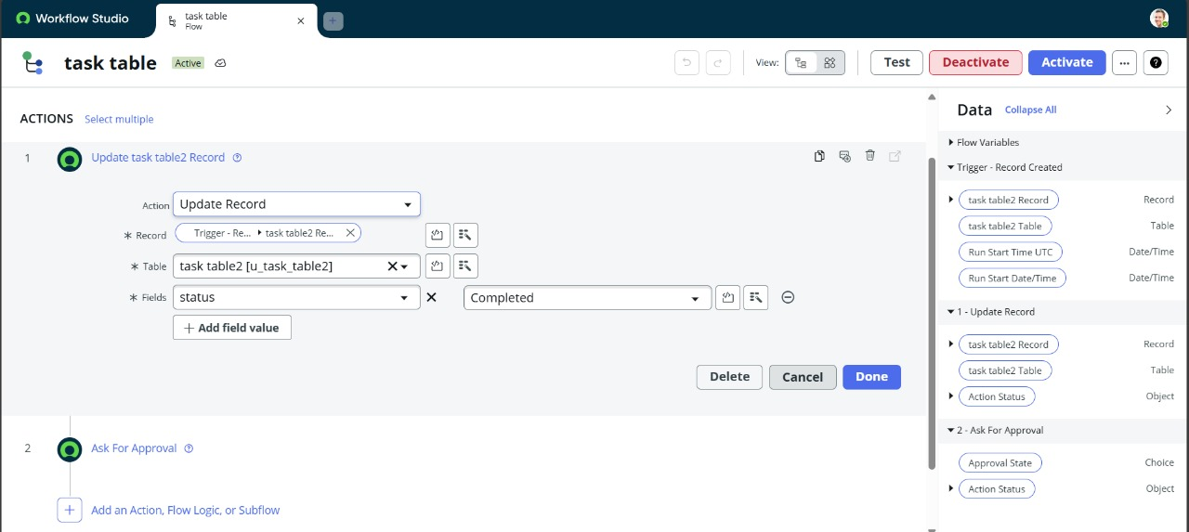

## Milestone 6: User and Group Table Creation

* Created two tables:

**User Management** – stores user details and assigned roles

**Group Management** – stores group names, members, and linked permissions

* Linked Users to Groups and Roles via reference fields

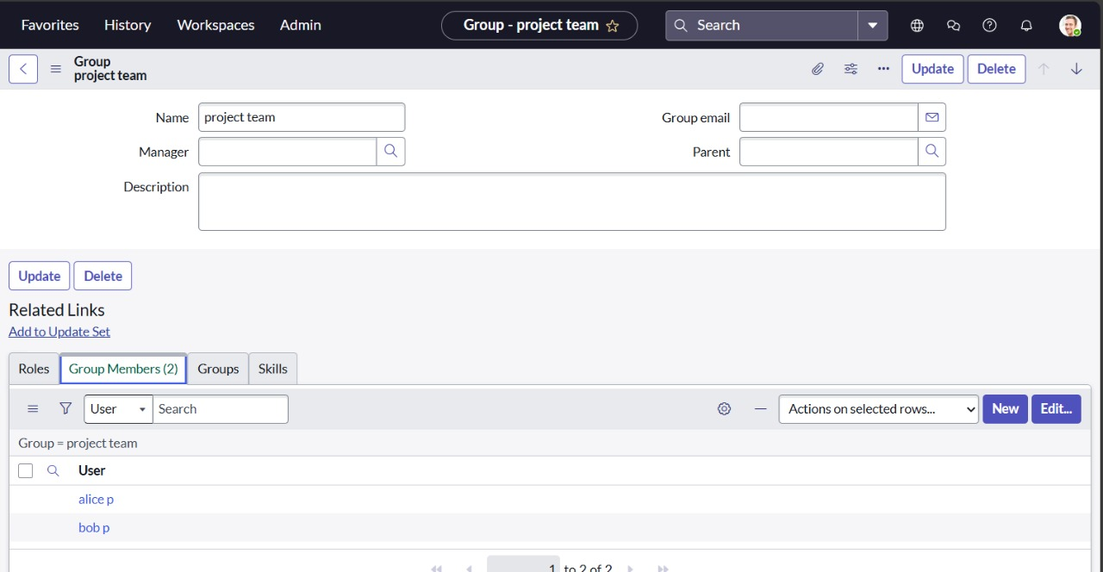

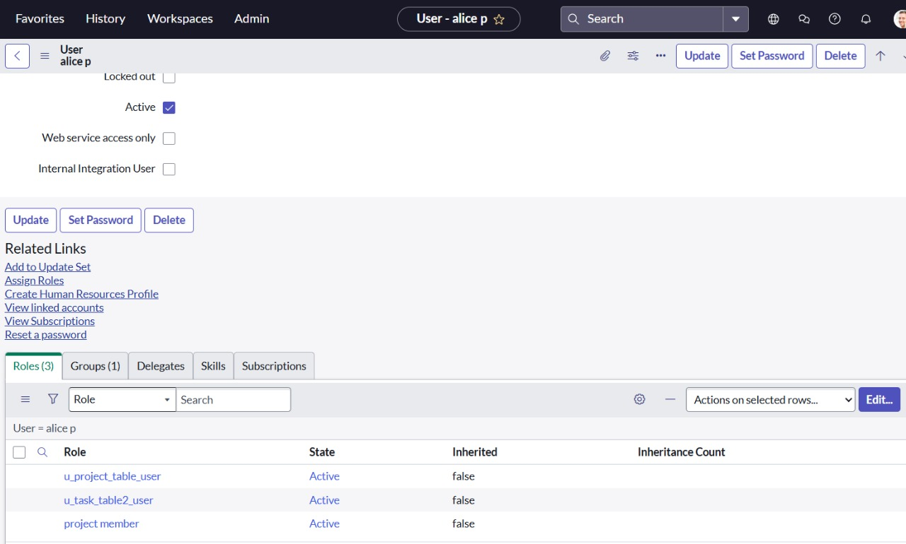

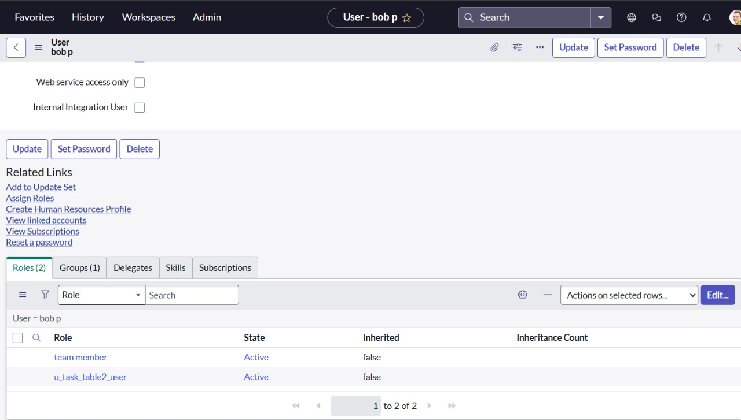

## Milestone 7: Workflow Implementation

* Designed a workflow for task management with the following states:

1. Task Created
2. Task Assigned
3. In Progress
4. Completed
5. Closed by Manager

* Used ServiceNow Flow Designer to automate transitions and set up notifications

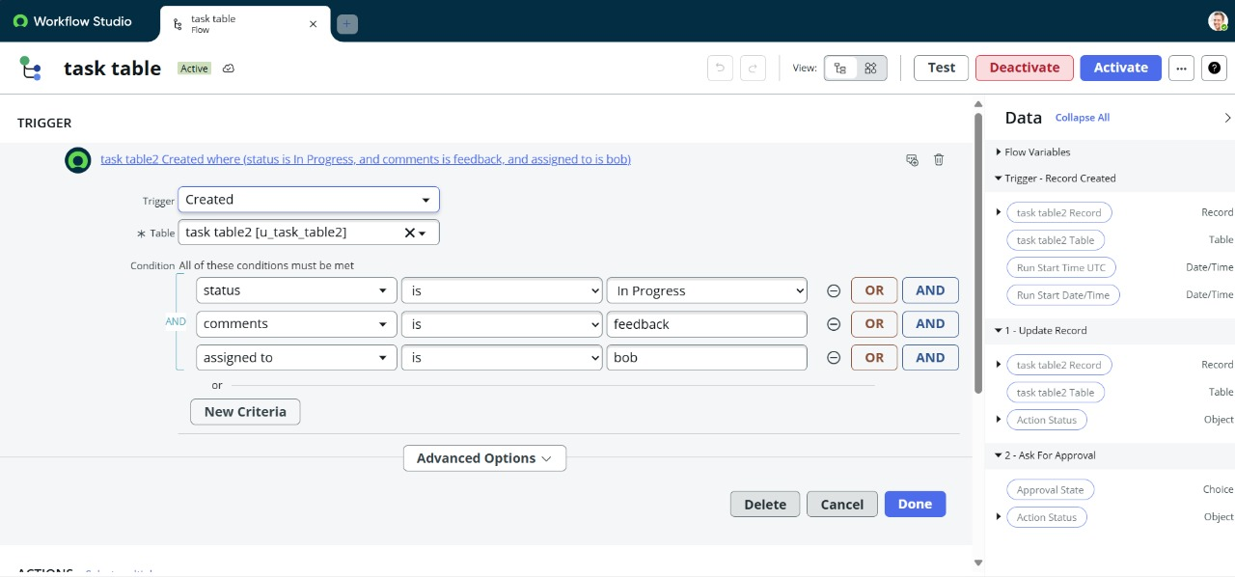

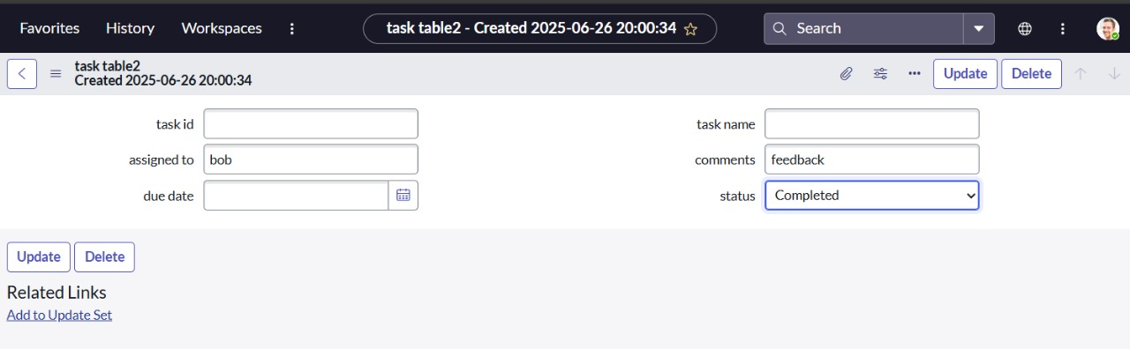

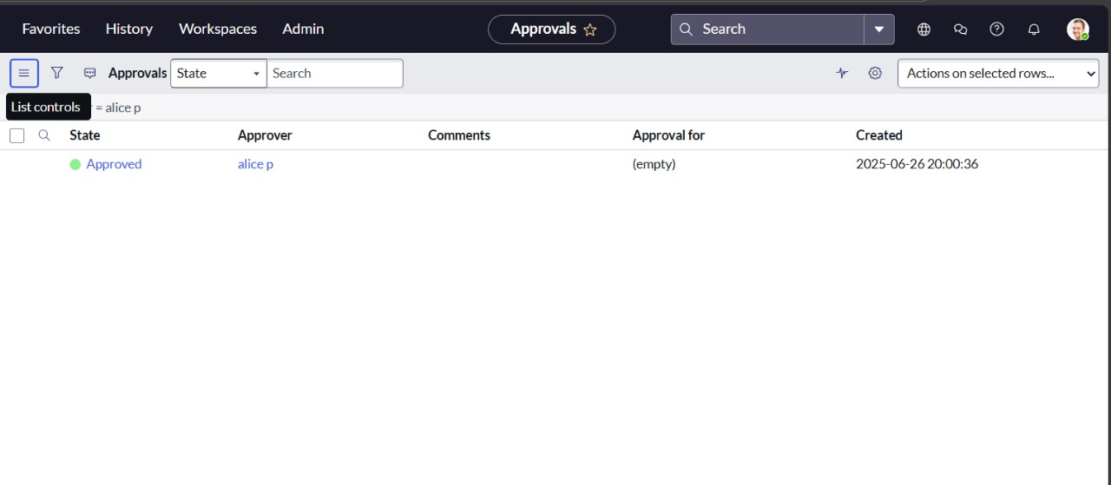

## Milestone 8: Business Rule Setup

* Created Business Rules to:

1. Prevent task reassignment by unauthorized users
2. Trigger alerts on status changes
3. Maintain logs of changes per user

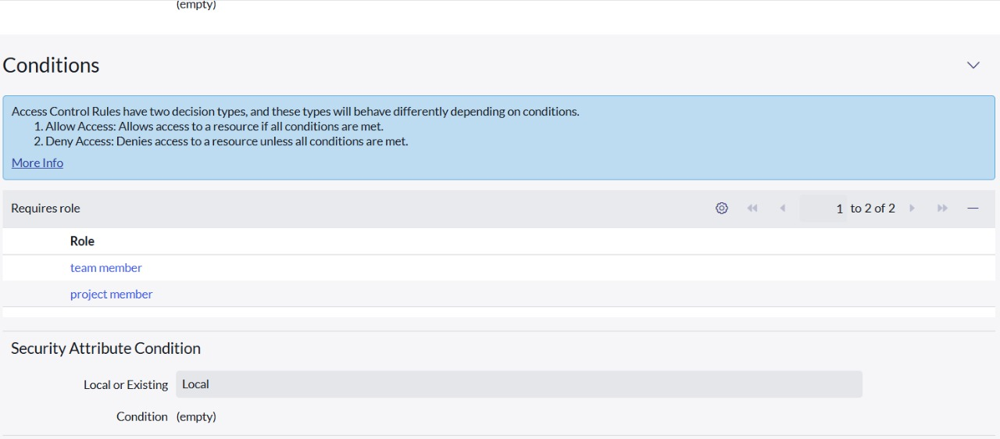

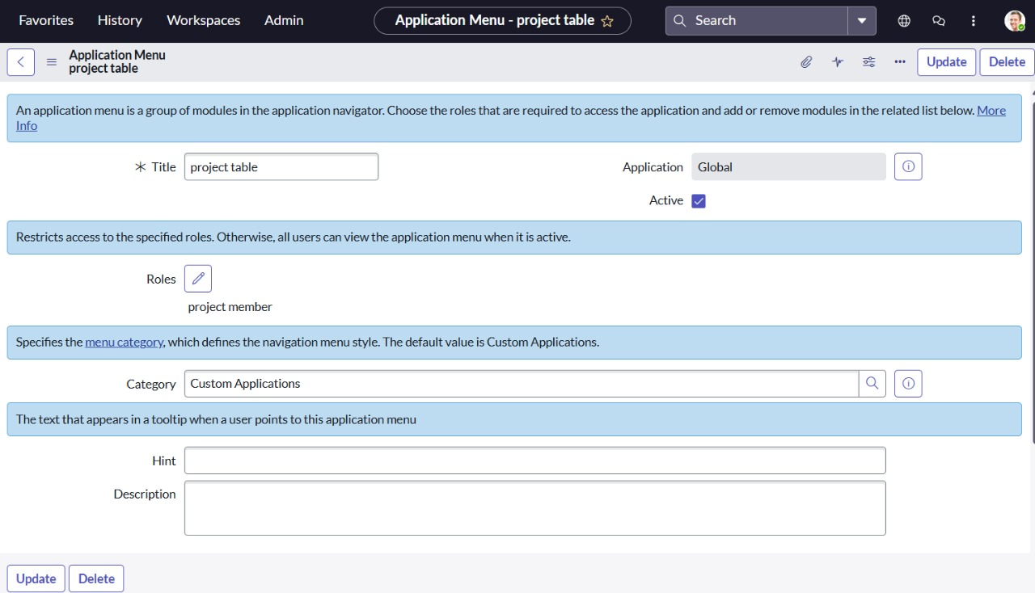

## Milestone 9: Configure Relationships

* Linked Task Table with User and Role tables
* Created Related Lists to display task ownership under user profiles
* Enabled Manager-only visibility to closed/completed tasks

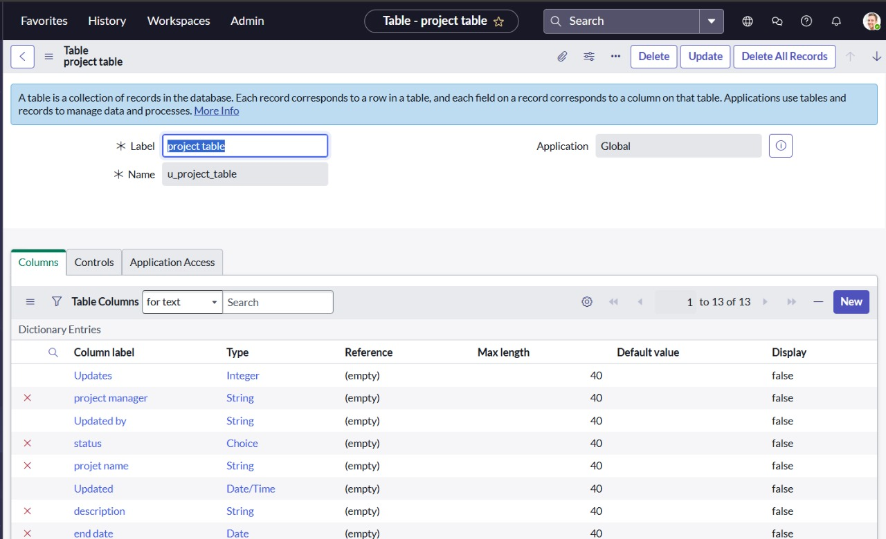

## Milestone 10: Testing & Validation

* Tested workflows by logging in as both Alice (Manager) and Bob (Team Member)
* Verified:

1. Bob could only update assigned tasks
2. Alice had full access
3. Status changes triggered alerts
4. Unauthorized actions were blocked

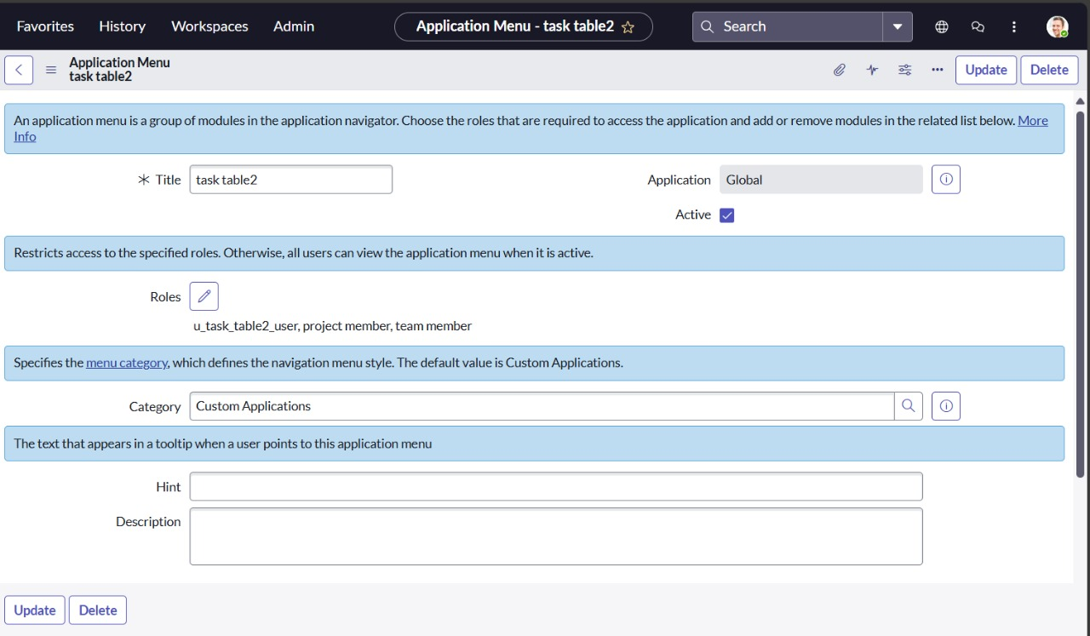

**6. FUNCTIONAL AND PERFORMANCE TESTING**

**6.1 Performance Testing**

The system was tested for:

· Verified correct task status transitions

· Tested role-based form views

· ACLs restrict unauthorized access

· Notifications triggered upon task updates

#### **6.2 Performance Testing**

* Quick login (<2 sec)
* Real-time updates reflected on dashboards
* Business rule triggers completed within expected limits

**7. RESULTS**

**7.1 Creation Screenshots**

**assigning table access to application:**





**Creation of ACL:**



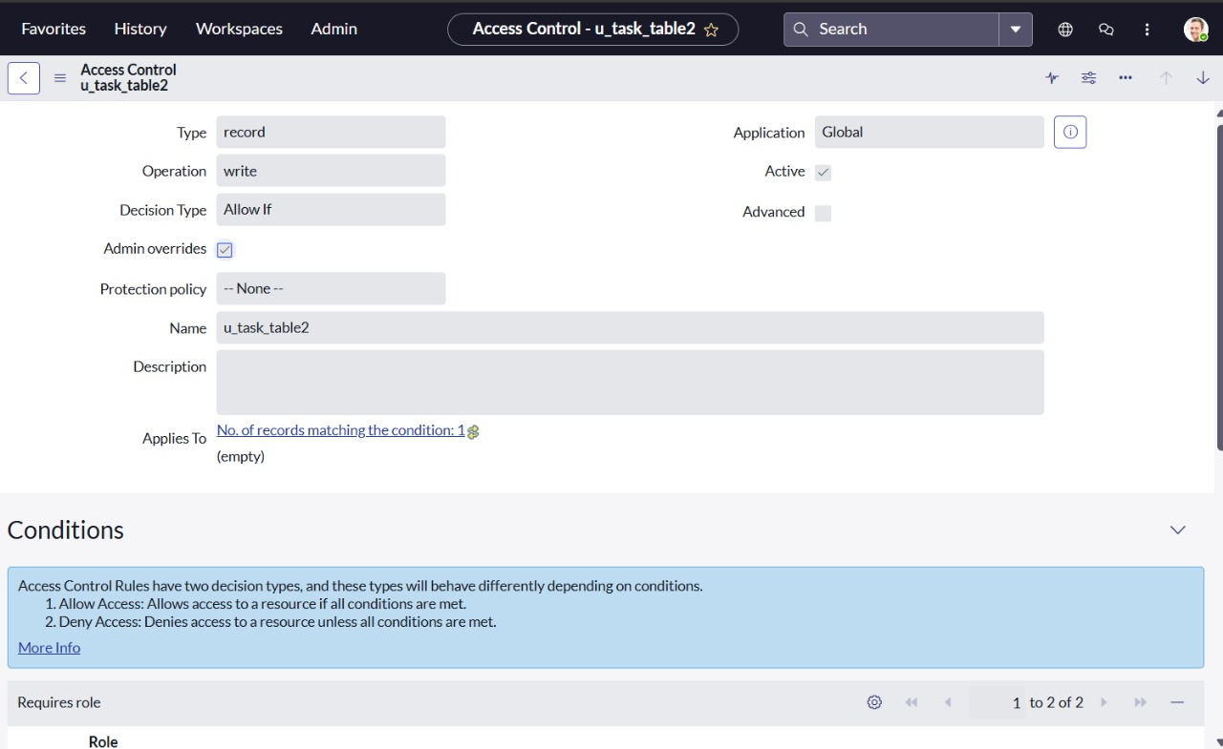

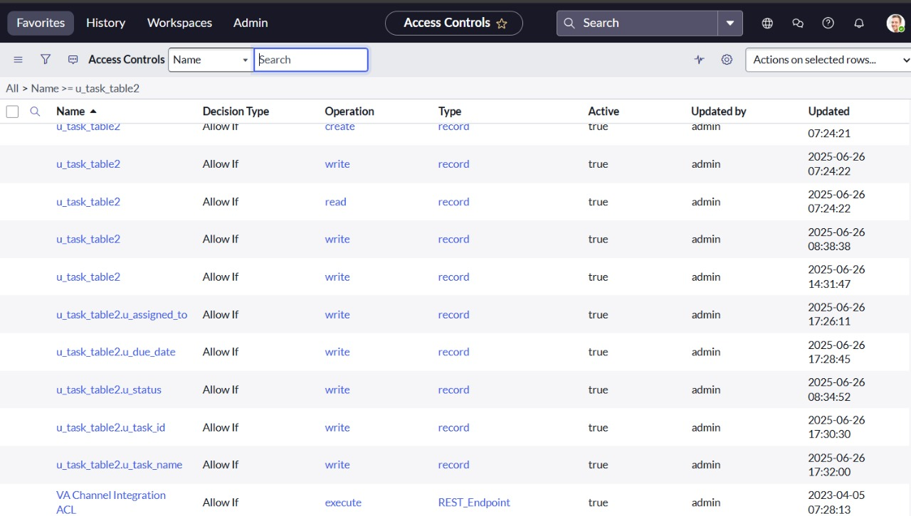

**Creation of flow to assign operations:**

**7.2 Output Screenshots**













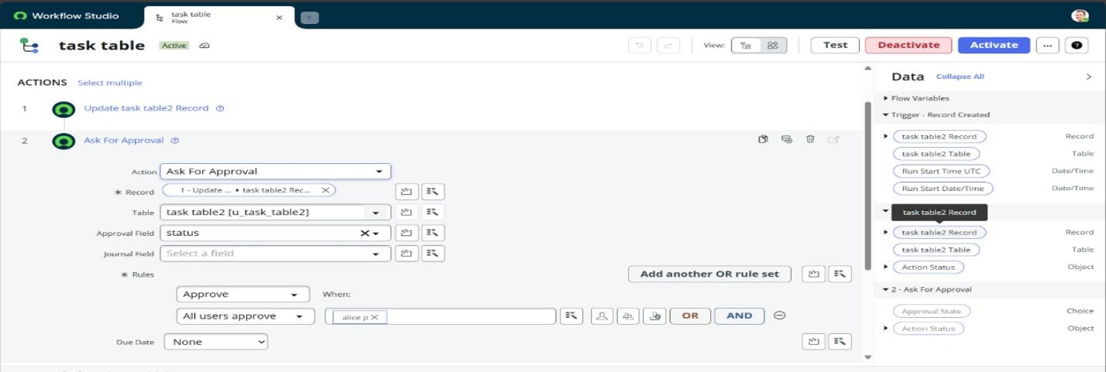



**8. ADVANTAGES & DISADVANTAGES**

**Advantages**

* Automation reduces manual work
* Streamlined team management
* Increased accountability

**Disadvantages**

* Customizations may need advanced scripting.
* Limited features without enterprise license.
* Requires knowledge of ACL setup.

**9. CONCLUSION**

The solution addresses key gaps in team project management by implementing role-based access and task workflows on ServiceNow. The platform now supports clarity, accountability, and structured project execution, improving team efficiency.

1. **FUTURE SCOPE**

· Integrate with email/calendar tools

· Role-based mobile app access

· Task analytics and heatmaps

· Multi-project and cross-team integration